**REDIS INSTALLATION ON WINDOWS:**

Here is the link to direct download Redis on Windows system.

**Direct Link =** [**https://github.com/microsoftarchive/redis/releases/download/win-3.0.504/Redis-x64-3.0.504.msi**](https://github.com/microsoftarchive/redis/releases/download/win-3.0.504/Redis-x64-3.0.504.msi)

When the above link is clicked then it redirect to a github repo and the download start automatically.

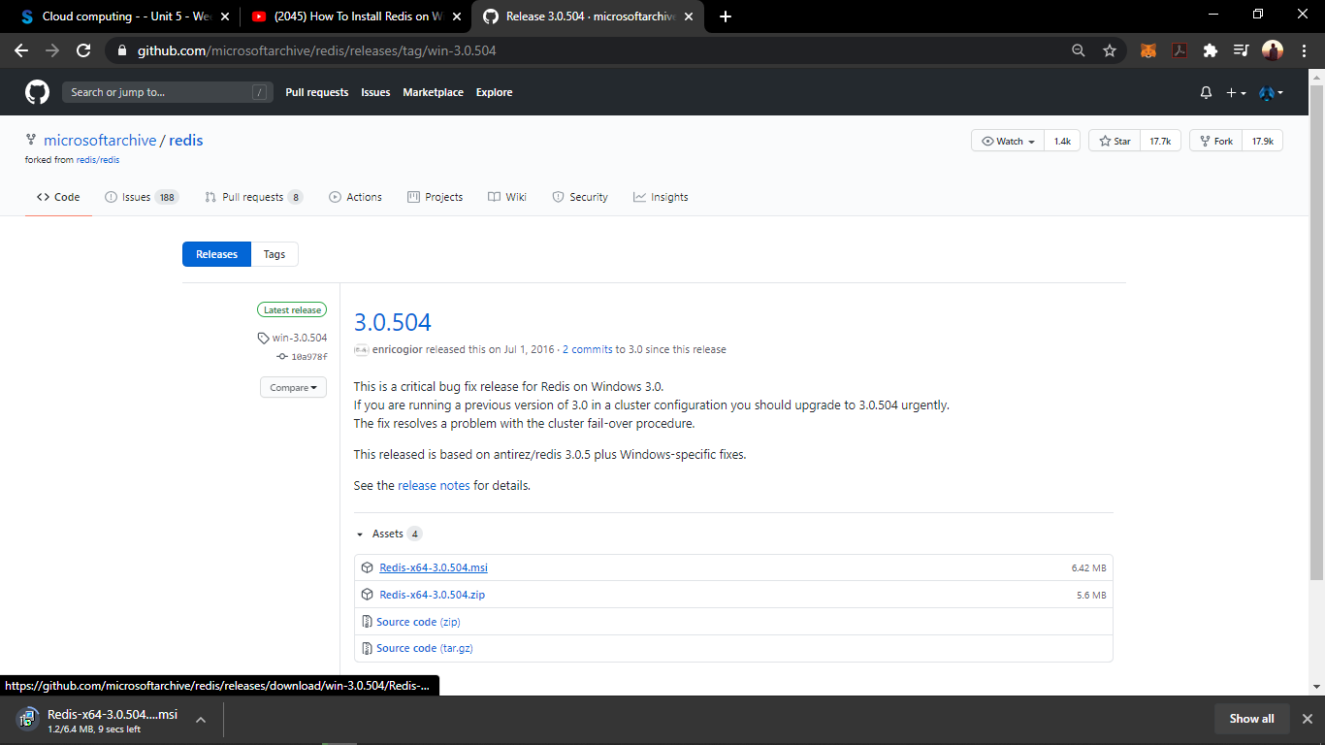

If the download didn’t start automatically then click “Redis-x64-3.0.504.msi” file and now download starts as shown in the previous image.

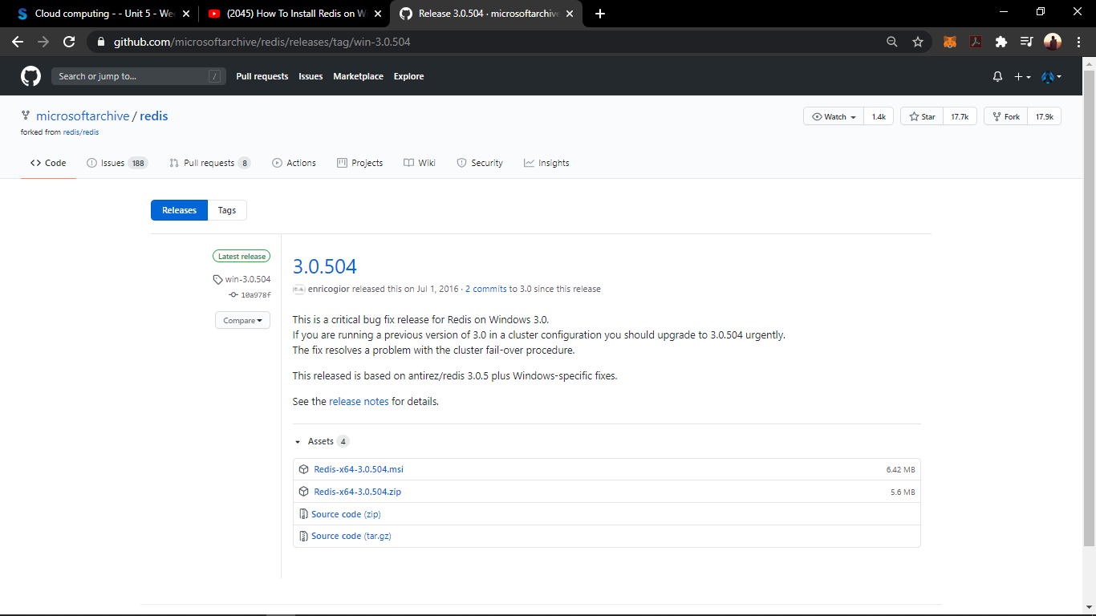

Once “Redis-x64-3.0.504.msi” file has downloaded then open that file which opens the installation wizard and then click “Next” button.

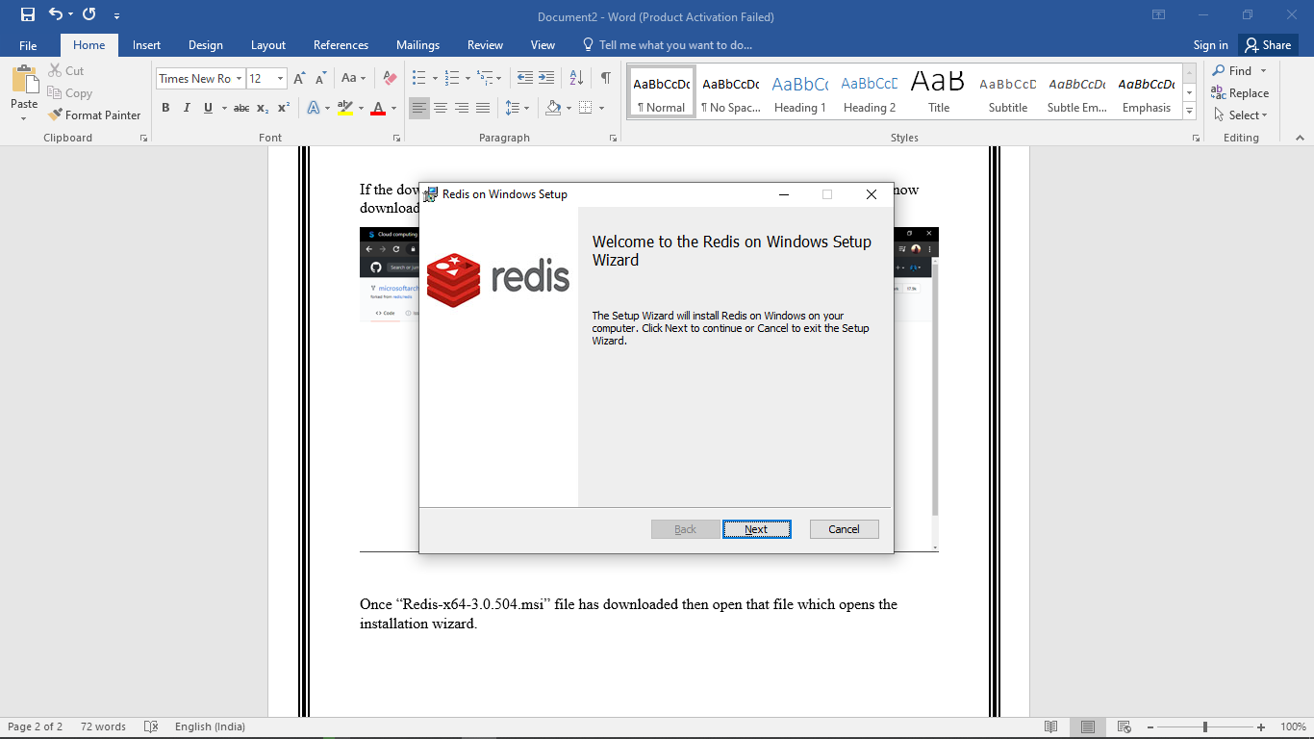

On clicking the “Next button”, next wizard appears where check the check box by agreeing the teams and conditions of the licence policy and then click “Next” button.

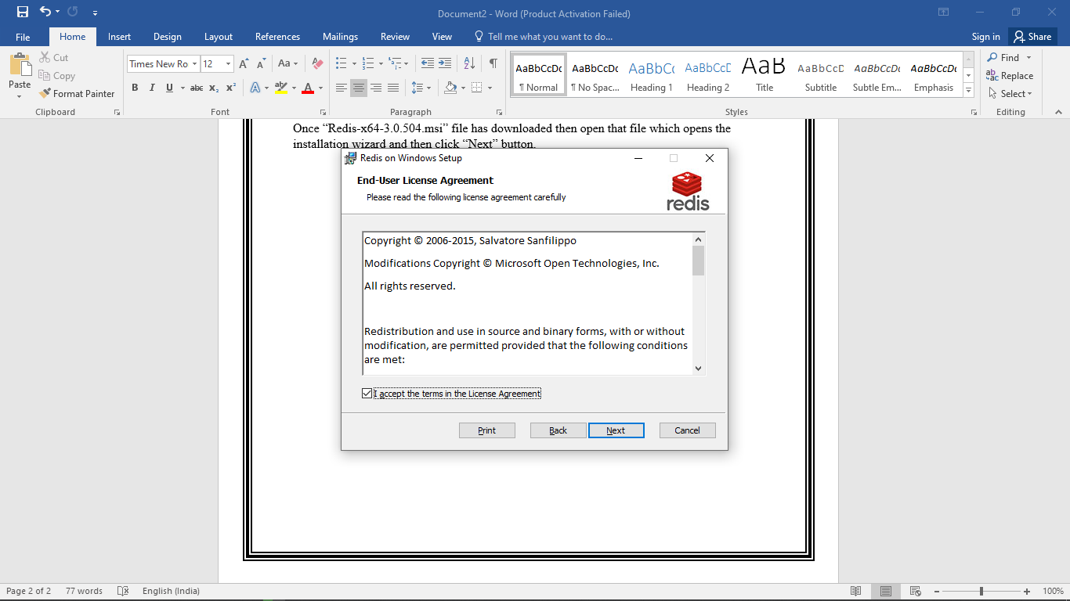

The next windows prompt is to set location to install Redis, by default it will be set to C drive. Leave it as such as, if no reason to change the installation location. Also check the check out to set Redis in PATH variable. Then click “Next” button.

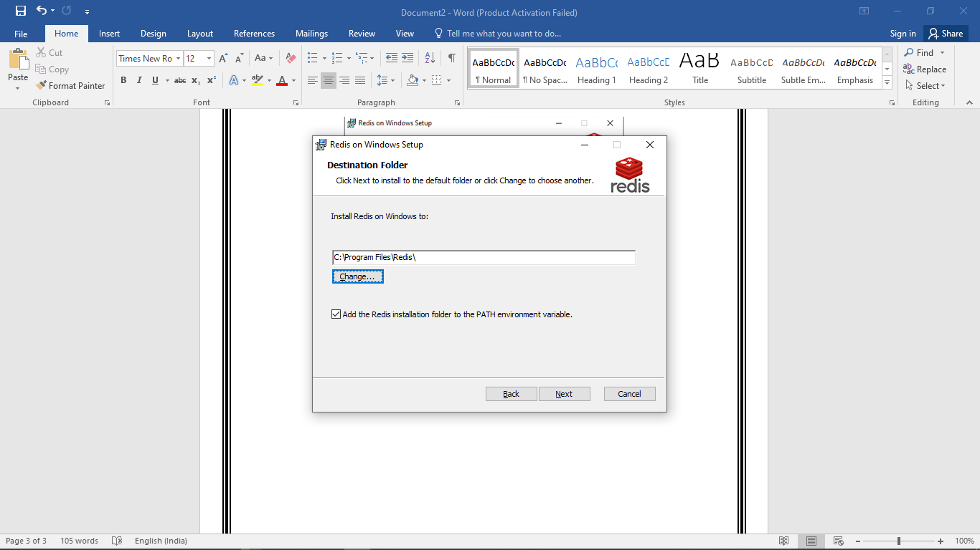

The next window will allow to set the “port number to run Redis”, leave as a default value and click “Next” button.

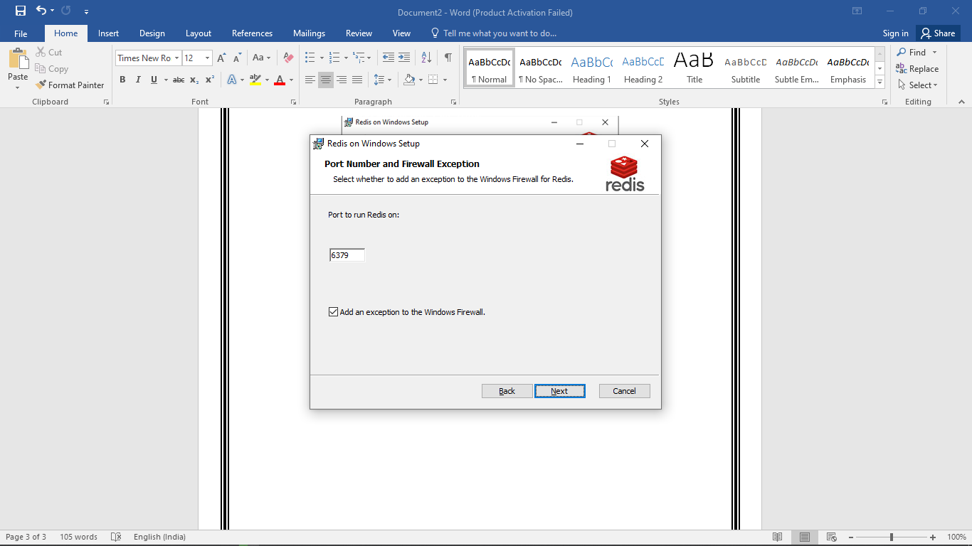

The next window will allow to set the “Max Memory Limit”, leave as a default value and click “Next” button.

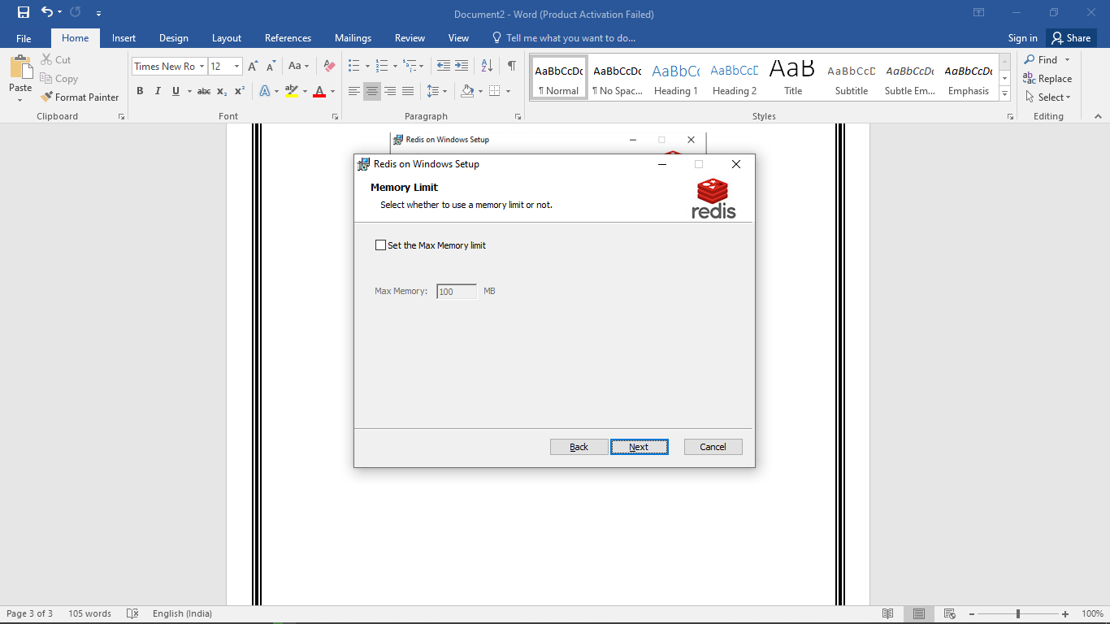

The next window will be “Install” window, where click “Install” button.

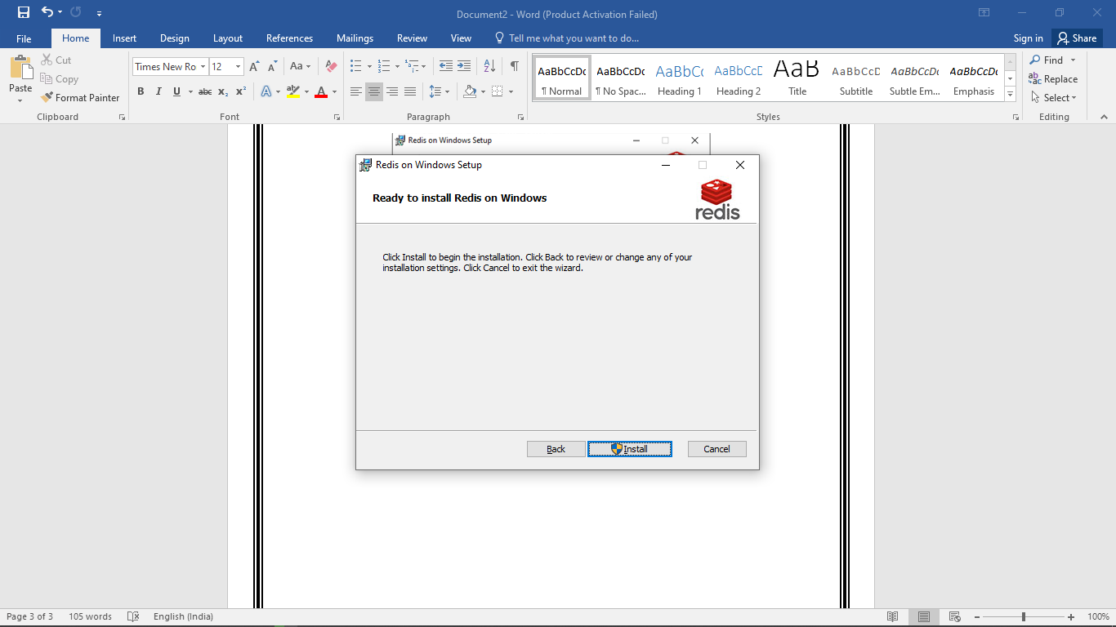

Then the next window will start the installation process and ask for permission to install, then click “YES” and wait for the installation process to complete.

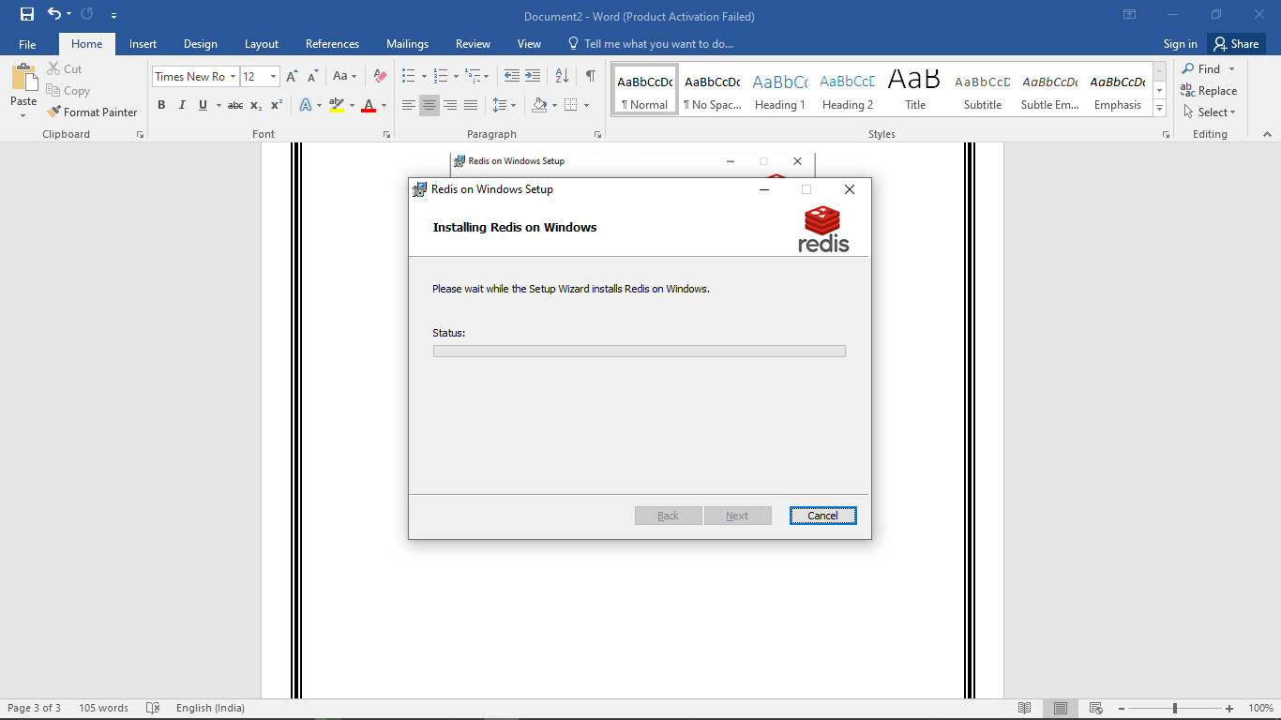

Once the installation process has been completed then the Final window will pop-up, click “Finish” button.

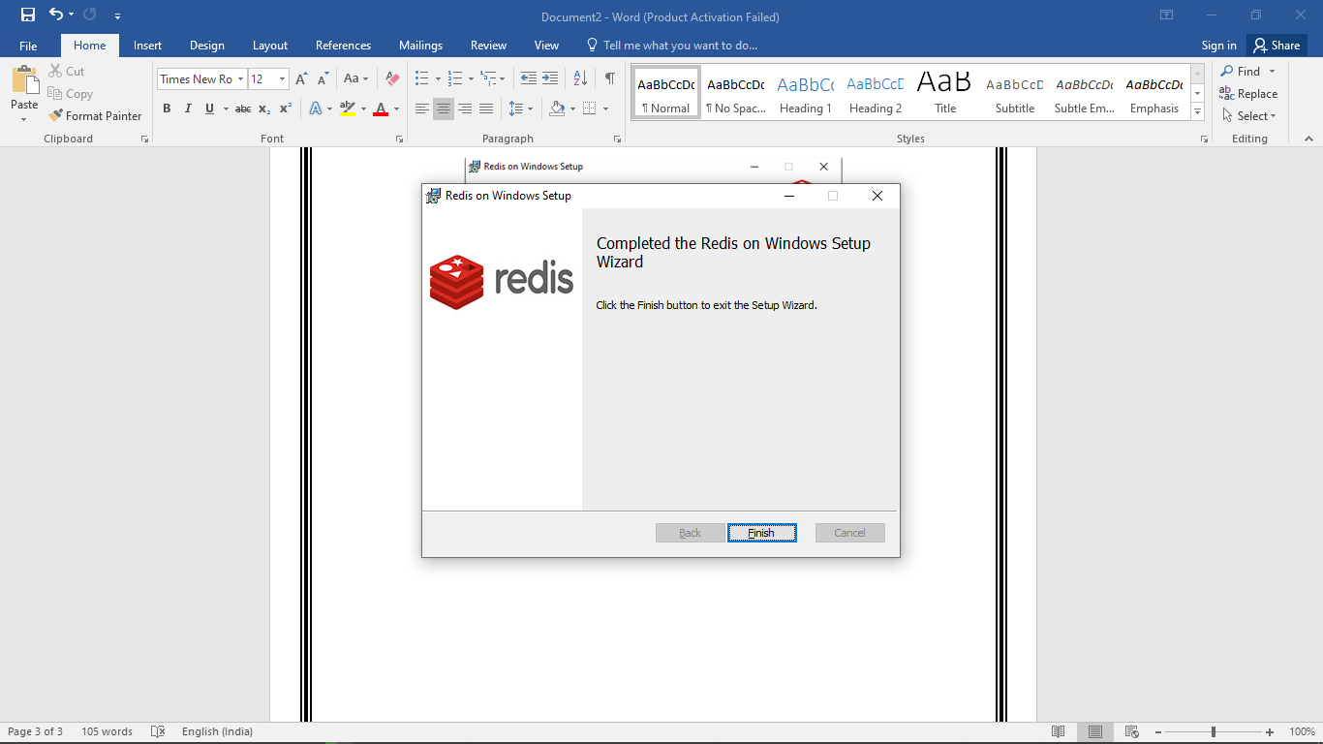

Open the Redis installed folder to confirm the successful installation of Redis and click “redis-cli” file to open Redis command prompt.

**NOTE:** I have installed my Redis in Local Disk D.

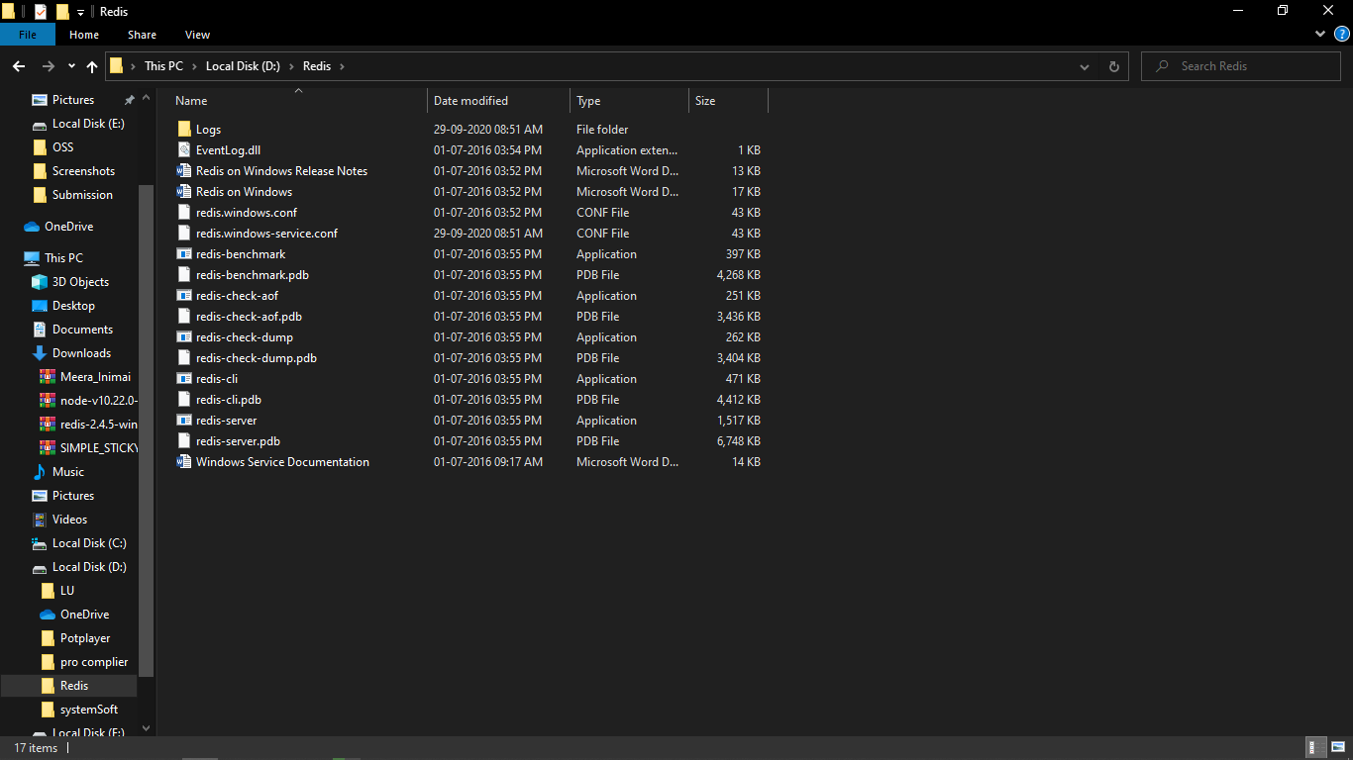

The following command prompt will appear.

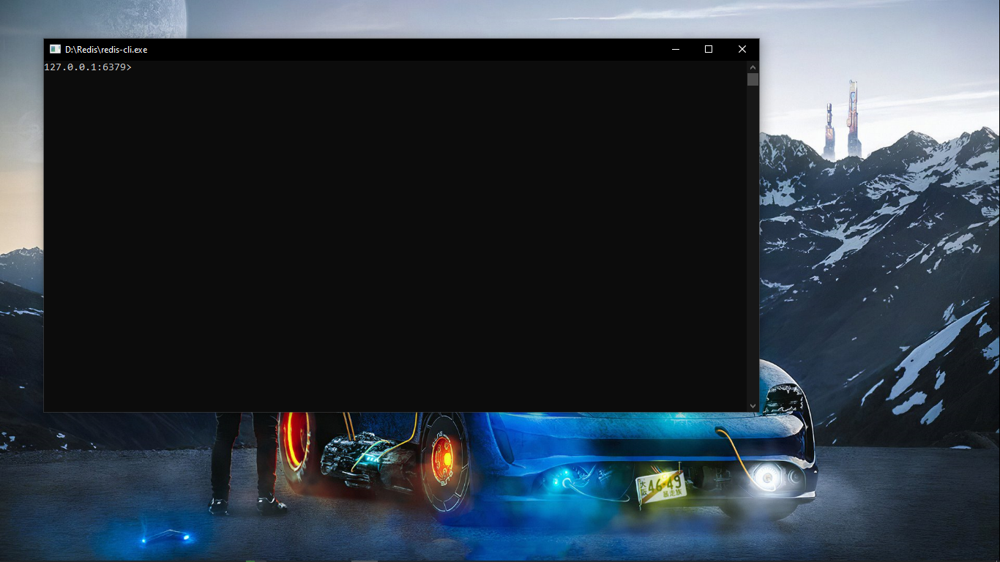

Type the command “PING” to check for proper connection, if it returns “PONG” as output then the redis is connected properly.

